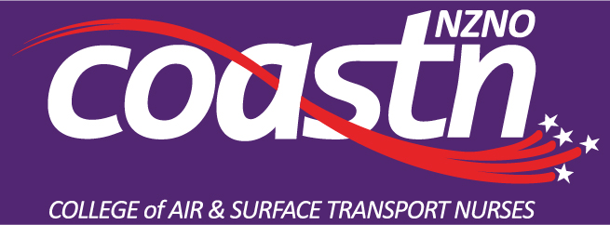
Aeromedical Retrieval Course Co-ordinator Application
Please forward applications to Lynette Will COASTN chair lynettewill@hotmail.com
With this application please attach a current CV and any other supporting information.
For this role: good IT skills are advantageous. The ability to foster positive relationships on a multi-displinary level is essential.
There is expectation to feed back to the COASTN committee, at the AGM and work in conjunction with the committee.
Name:
Address:

Phone number:
Why do you want to apply for this role?

What experience have you in leadership, and can you give some examples?

What can you bring to COASTN in this role? (Inc indication if wanting to be on the committee or not)

Detail all your previous and current roles within the aeromedical field:
Any other relevant information to support your application:
References:

