Waikato Aeromedical Symposium
‘It’s all about the patient’
The Verandah Function Centre, Hamilton Lake
2nd November 2018

HELPFUL INFORMATION

Getting there:

The trip from Hamilton Airport to the Hamilton Lake is 13.2km, approx. 14 min travel time. There are over 300 complimentary car parking spaces at the lake.

From Hamilton Airport Super Shuttle’s door-to-door service covers every flight, every day. Each luxury mini-coach has 11 passenger seats and is equipped with a luggage trailer that will cater for all your luggage requirements
Ph: 0800 748 885
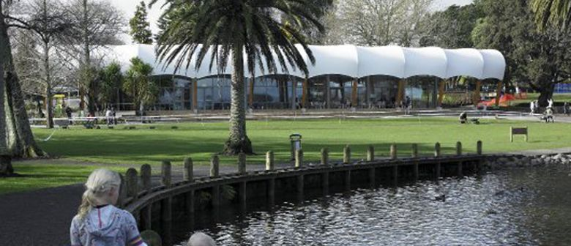
Email: reservations@supershuttle.co.nz
Website: www.supershuttle.co.nz

Hamilton Taxis
Ph: 0800 477 477

Accommodation:

As the venue is located close to Waikato Hospital and all hospital accommodation is located off-site it is recommended that you book your accommodation early to avoid disappointment.
There are a few websites that offer no deposit and free cancellation such as Wotif.com, cancellations are often accepted up to 72 hours prior to booking date.

Accommodation on Wotif.com located close to The Verandah Function Centre (Hamilton Lake Domain, off Ruakiwi Rd):

Astra Motor Lodge from $172 p/n
BKs Hamilton from $205 p/n
Ventura Inn & Suites Hamilton from $145 p/n
Lake Point Motel from $115 p/n
Ashwood Manor Motor Lodge from $131 p/n

Social After Function

We would like to invite you to join us after the symposium to relax, chat and have some light refreshments

Only a short walk from the venue, access is easily available for taxis/shuttles when needed
(address will be provided on the day)

COASTN Aeromedical Symposium
“It’s All About the Patient”
2 November 2018
The Verandah Function Centre, Hamilton Lake, Hamilton

REGISTRATION FORM
Name:
Address:
Telephone:
Email:
NZNO Member | Yes/No  NZNO Member No.:
Registration Fee | $150 for COASTN members (Early bird before 1 October) includes all catering  $170 non COASTN members (after 1 October)
Do you have any special dietary requirements?

Payments:
Please pay by internet banking to:
Account details: ANZ 01-05050713049-00

Please ensure your payment reference includes your surname.

Please return the completed registration form by 1 October to:
anju2372@yahoo.co.nz and Leanne.Stokes@waikatodhb.health.nz

