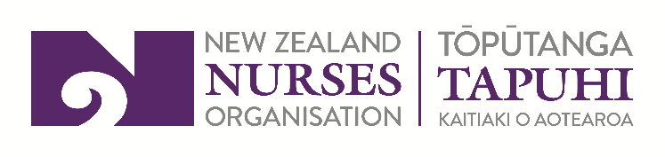

NZNO HNZ Te Whatu Ora CA

Bargaining process
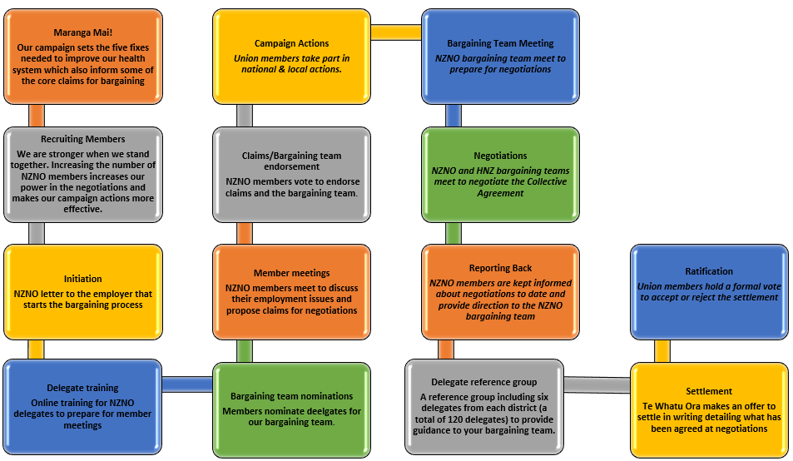

Maranga Mai! and other core claims
These are broad claims we propose to take into bargaining, covering issues which are important to members. The proposed claims describe how we propose to address the issues, while specific wording for these claims will be provided to members before the claim’s endorsement ballot.
Our Maranga Mai! campaign sets the five fixes needed to improve our health system. ‘Maranga Mai!’ means ‘Rise Up!’ and this campaign is a call for NZNO members, whatever sector they work in, to come together and take united action.
We want to win the political and resourcing commitments needed to address the nursing shortage crisis permanently – and across the whole health sector.

The five fixes are:
- Te Tiriti actualised within and across the health system;
- More nurses across the health sector;
- Pay and conditions that meet members’ value and expectations;
- More people training to be nurses;
- More Māori and Pasifika nurses.
The five fixes inform the core claims for bargaining, either directly, e.g. through wages and conditions that meet nurses and midwives value and expectations, or indirectly, by creating a health sector which attracts and retains nursing and midwifery staff.

Maranga Mai! core claims:

Pay claim
We propose a wage claim which addresses the increased cost of living faced by members.

Safe working conditions
These claims fall into two categories.
Where CCDM is not yet implemented, minimum staffing levels using nurse to patient ratios will apply. These ratios will be based on current ratios in place in other territories and domestic and international research. The ratios will form a minimum staffing level and can be increased where needed.
Strengthening the role of Health and Safety reps. This year, we have increased our use of the Health and Safety at Work Act to ensure a safe workplace for members, often with a particular focus on staffing levels. This has seen a number of H&S reps issue provisional improvement notices (PIN notices) to Te Whatu Ora with recommendations on improving the situation, many of which have been upheld by WorkSafe, the Government Department responsible for health and safety. We propose changes to our collective agreement which improve training for health and safety reps and strengthens their role in the workplace.

Actualising te Tiriti
Māori members are often asked to use their cultural knowledge and skills in the workplace, e.g. playing a leading role in powhiri, or providing guidance about te ao Māori. We propose a claim which provides recognition for members using these skills / knowledge.

Unfinished business
Following the last negotiations we agreed to keep working with Te Whatu Ora on three other claims we weren’t able to agree on; professional development for health care assistants; access to clinical supervision; and recognition for members performing the ‘nurse in charge’ or ‘duty leader’ role. We have received information from Te Whatu Ora about what the various districts do in these areas and we propose to take these claims back into bargaining. Another claim advanced in the previous negotiations is recognition for nurse prescribers, which remains an issue which needs to be addressed in the collective agreement.

