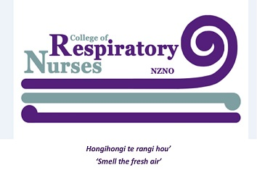

NOMINATION FORM FOR COLLEGE OF RESPIRATORY NURSES
NATIONAL COMMITTEE
(Please print clearly)

………………………………………………… ………………….............................
(Surname) (Given Name)

for the position of Committee Member College of Respiratory Nurses

Signed: ......................................................... Date: ...................................................

This section to be completed by Nominee

I, accept nomination as Committee Member of the College of Respiratory Nurses

Address (Personal) Address (Business)
……………………………………………. …………………………………………….
.…………………………………………….
Ph/Fax: Ph/Fax: ……………………………………

Email: Email: ……………………………………..

Area of current work: ……………………………………………………………………………………………………………

NZNO Membership No. ………………………………………………
Length of time as member of College of Respiratory Nurses *……………………………………………………..
Work Experience, including level of responsibility:

Explain briefly why you think you are suitable for this position (if relevant include previous committee experience)

Signature Date

Please attach a recent photograph, passport type or close-up preferable.

Please return the completed nomination form to Diana Geerling, Returning Officer, NZNO, PO Box 2128, Wellington or email diana.geerling@nzno.org.nz by 3 March 2020.

To be valid this form must be signed by both parties and be received by the closing date.

