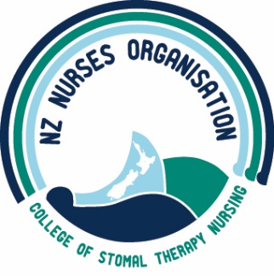

NOMINATION FORM FOR COLLEGE OF STOMAL NURSING
NZNO NATIONAL COMMITTEE
(Please print clearly)

………………………………………………… ………………….............................
(Surname) (Given Name)
for the position of Committee Member College of Stomal Nursing

Signed: ......................................................... Date:...................................................

This section to be completed by Nominee

I, accept nomination as Committee Member of the College of Stomal Nursing

Address (Personal) Address (Business)

Ph/Fax: Ph/Fax:

E-mail: Email:

Area of current work:
NZNO Membership.
Length of time as Member of College of Stomal Nursing *……………………………………………………..
Work Experience, including level of responsibility:

Explain briefly why you think you are suitable for this position (if relevant include previous committee experience)

Signature Date

Please attach a recent photograph, passport type or close-up preferable.

Please return the completed nomination form to:
Nicky Bates (nicky.bates@wdhb.govt.nz)
by 12 August 2020

To be valid this form must be signed by both parties and be received by the closing date.

