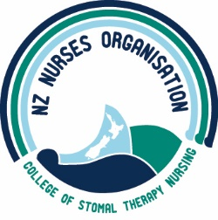

Policy for Bernadette Hart Award

PROCESS  - The Bernadette Hart Award (BHA) will be advertised in the NZNOCSTN Journal “The Outlet”.  - The closing date for the BHA applications is 30 November each year.  - The NZNOCSTN National Committee will consult and award the BHA within one month of the closing date.  - All applicants will receive an email acknowledgement of their application.  - All applicants will be notified of the outcome, in writing, within one month of the closing date.  - The monetary amount of the award will be decided by the NZNOCSTN National Committee. The amount will be dependent on the number of successful applicants each year and the financial status of the BHA fund.  - The name of the successful applicant(s) will be published in the NZNOCSTN Journal “The Outlet”.  - The BHA Policy will be reviewed annually by the NZNOCSTN National Committee | CRITERIA  - The applicant(s) must be a current member of the NZNOCSTN and have been a member for a minimum of one year.  - Successful applicant(s) must indicate how they will use the award. The award must be used in relation to Stomal Therapy nursing practice.  - The applicant (s) previous receipt of money (within the last five years) from the NZNOCSTN and/or the BHA will be taken into consideration by the NZNOCSTN National Committee when making their decision. This does not exclude a member from reapplying. Previous receipt of the BHA will be taken into account if there are multiple applicants in any one year.  - The funds are to be used within 12 months following the receipt of the BHA.  FEEDBACK  - The successful applicant(s) agrees to either:  - Submit an article to “The Outlet” within six months of receiving the BHA. The article will demonstrate the knowledge gained through use of the BHA  - To present at the next NZNOCSTN Conference. The presentation will encompass the knowledge/nursing practice gained through the use of the BHA.
Implemented: September 1998
Reviewed: November 2021
Next Review: November 2026

