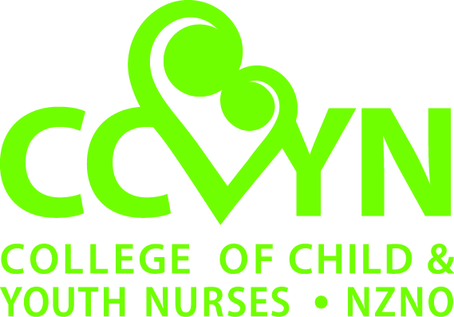

College of Child & Youth (CCYN) Nurses
Scholarship Application
The CCYN scholarship is available for registered nurses working in the area of child/ youth health who wish to attend an international/ national conference relating to child/ youth health.
Criteria for scholarship
- Applicants must be a NZ resident, current NZNO member and a CCYN national section member for a minimum of one year.
- Applicants are required to complete the application form in full.
- Applicants are required to present an outline of the conference to the committee, their professional objectives for attending including why attendance is pertinent to their area of practice and how it will benefit their client group.
- Agrees to provide a written report for the CCYN newsletter within three months of attending.
- Where possible, applications must be submitted at least two months before the conference to allow sufficient time for consideration, processing and checking membership status with NZNO.
Scholarship administration
- Twice a year the scholarship will be up to $600.00 to be divided amongst eligible applicants at the committee’s discretion. If there is only one applicant, they will not necessarily receive the full scholarship. If the first $600.00 for the year is not allocated this will be transferred to the second application round for the year to make the total amount of funds to be awarded each year $1,000.
- Priority of fund allocation will be given to first time applicants and those who have not received the scholarship in the previous three years.
- Timeline - The applications for scholarships will be considered and voted on at each committee meeting.
- There are five committee meetings per year.
- The scholarship is cumulative within one financial year. The cumulative total scholarship is $1,000 each financial year from 1 April to 31 March.
- Following the meeting, applicants will be notified in writing if their request has been accepted or declined, and
- Only applicants meeting the above criteria will be reviewed.

This process will be reviewed every three years.

APPLICATION FORM
Name of Applicant:
Contact Address:
(You must live in New Zealand)
Phone Number: | Work:  Mobile/Home:
Email Address
NZNO Membership No.
(You must be a current financial member of NZNO)
Job Title/Position
How long have you been a member of CCYN?
Please indicate the amount you are requesting:
Title/Theme of Conference:
Location:
Dates:
Who is your target audience? (e.g.: managers, practicing staff)
Please itemise the proposed conference expenses:
Are you presenting at this conference? | Yes ☐ No ☐
If so, what is the title of your presentation?
Outline professional objectives or learning outcomes for attending:
Why/ how will this course benefit your professional development and your client group?
Have you received or applied for other grants and/ or sponsorships or are other organisations making a contribution for this conference?
If yes, please provide give details
Mandatory requirement: Please attach any calls for abstracts, flyers and/ or draft programmes, travel and accommodation quotes etc. related to this conference.
Further criteria for funds allocation
- You agree to the CCYN publishing your name as a recipient.
- You agree to the Co-Editors of Kai Tiaki (or other members of NZNO staff) contacting you for publicity purposes e.g.: a story in Kai Tiaki
- To ensure fair and equitable consideration of all applications and distribution of funds, all parts of the form must be legible and complete with required information attached. Additional information can be provided as an appendix.
- I declare the contents of this application form to be true and correct.
- I agree that if the conference is cancelled any funds will be returned in full to CCYN
- I agree to present a written report to the CCYN Executive Committee within three months attending the conference. This report will be published in the CCYN newsletter for all CCYN members.
Signature: Date: _________
Please email the completed form to: secretary.ccyn@gmail.com
- On receipt of your application you will be sent a letter/ email message from CCYN. Please contact us if you do not receive a letter/ email message within two weeks.
- Applications are reviewed by the College of Child & Youth Nurses (CCYN) Committee. Payment is made to successful applicants within six weeks of the closing date.

N.B.: The decision of the CCYN Executive Committee is final.

