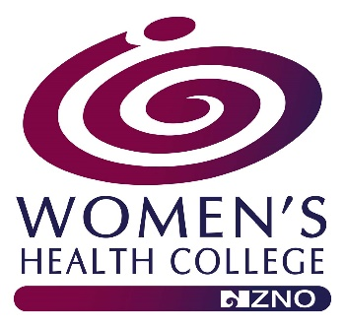

WOMEN’S HEALTH COLLEGE, NZNO
EDUCATION AWARD APPLICATION FOR
QUALIFIED NURSES/MIDWIVES:
Applications are assessed four times annually at Women’s Health College Committee (WHC) face-to-face meetings. These meeting dates vary slightly each year. If you have not received any correspondence about your application within 4-6 weeks, please contact WHC Administrator, sally.chapman@nzno.org.nz
Name of Applicant
Address
Mobile
Email Address
NZNO Membership Number
(You must be a current financial member of NZNO).
Are you a member of the NZNO WHC?  (You must be a current member of the NZNO Women’s Health College to be eligible). | Yes ☐ No ☐
How much money are you requesting? (Maximum $450).
Please state if you are a
Nurse Practitioner, Registered Nurse, Registered Midwife or Enrolled Nurse?
If you work, please state your position and the organisation you work for
Please provide details of the conference/ study you seek funding for, including:
- conference or course title,
- provider or organiser,
- costs involved,
- dates, and
- length of conference or course.
Please include proof of enrolment/ attendance and a copy of the programme.
How will you use this conference/ study to benefit Nursing, Midwifery, or Healthcare in New Zealand?

Please outline all assistance (if any) you are receiving from your employer including:
- paid study leave,
- registration fees,
- travel costs etc.
In the event that the WHC committee approve your application, please supply your bank account details
Name of account holder:
Bank account number:

Please note:
- In the event that your course, conference or study is cancelled, or you are cannot attend any money you receive from the WHC, NZNO is to be returned with an explanation for the
non-attendance.
- Upon completion of your course, conference, study, you may wish to provide a paragraph about your experience for the WHC, NZNO newsletter.
This application must be complete, legible and
have the required information attached.
DECLARATION
I declare the contents of this application to be a true and correct record.
Signature:
Date:

Please email application to WHC Administrator, sally.chapman@nzno.org.nz A reply to your application will be sent within 4-6 weeks. If you do not receive one, please contact our Administrator.

The decision of the Women’s Health College NZNO National Committee will be final.

